Project Planning Phase
Project Planning Template (Product Backlog, Sprint Planning, Stories, Story Points)
Automated Network Request Management in ServiceNow
Date
Team ID
Project Name | Automated Network Request Management in ServiceNow
Maximum Marks | 5 Marks

Project Overview
Automating network request management in ServiceNow enhances operational efficiency by streamlining workflows, reducing manual interventions, and ensuring real-time updates. This project implements a fully automated and scalable network change management process in ServiceNow to automate user-initiated network requests, ensuring rapid fulfillment, audit-ready change records, and accurate configuration tracking.
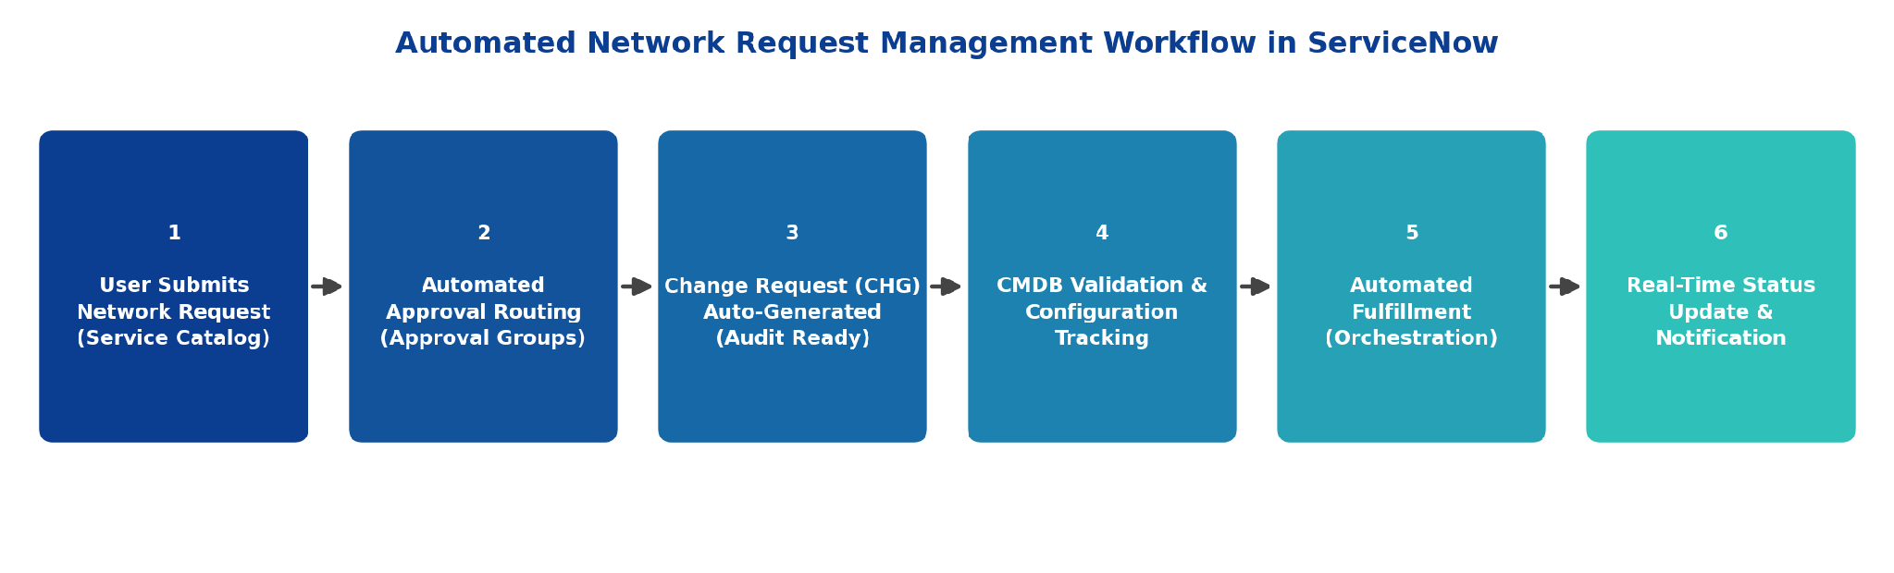
Figure 1: Automated Network Request Management Workflow in ServiceNow

Product Backlog, Sprint Schedule, and Estimation (4 Marks)
The table below presents the product backlog and sprint schedule for the Automated Network Request Management project. Requirements are organized into Epics, broken down into user stories (USN), and estimated using Fibonacci story points (1, 2, 3, 5, 8).
Sprint | Functional Requirement (Epic) | User Story Number | User Story / Task | Story Points | Priority | Team Members
Sprint-1 | Requirement Gathering & Catalog Design | USN-1 | As an admin, I can gather and document the functional requirements for automating network request management. | 2 | High
Sprint-1 |  | USN-2 | As an admin, I can design and configure the Network Request catalog item in the ServiceNow Service Catalog. | 3 | High
Sprint-1 |  | USN-3 | As a user, I can view the available network request types (new connection, IP change, VLAN change, firewall access) in the catalog. | 2 | High
Sprint-1 | Request Submission & Data Capture | USN-4 | As a user, I can submit a network request by filling out a dynamic catalog form with the required details. | 3 | High
Sprint-1 |  | USN-5 | As a user, I receive a unique request item number (RITM) immediately after submitting my request. | 1 | High
Sprint-2 | Workflow Automation & Approval Routing | USN-6 | As a system, I can automatically route a submitted request to the correct approval group based on request type and impact. | 5 | High
Sprint-2 |  | USN-7 | As an approver, I can approve or reject a network request directly from email or the ServiceNow portal. | 3 | High
Sprint-2 |  | USN-8 | As a system, I can automatically escalate a pending approval once its SLA is breached. | 5 | Medium
Sprint-2 | Change & Configuration Management | USN-9 | As a system, I can auto-generate an audit-ready Change Request (CHG) record once all approvals are complete. | 5 | High
Sprint-2 |  | USN-10 | As a network engineer, I can view the Configuration Item (CI) details linked to a request from the CMDB. | 3 | High
Sprint-2 |  | USN-11 | As a system, I can validate CI dependencies and detect conflicts before implementation begins. | 3 | Medium
Sprint-3 | Fulfillment Automation | USN-12 | As a system, I can trigger automated network configuration scripts through Orchestration / MID Server once a change is approved. | 8 | High
Sprint-3 |  | USN-13 | As a network engineer, I can view the real-time fulfillment status of a request on its record. | 2 | High
Sprint-3 |  | USN-14 | As a system, I can automatically update the CMDB once the network change is implemented in production. | 5 | High
Sprint-3 | Notifications & Real-Time Updates | USN-15 | As a user, I receive real-time email and portal notifications at each stage of my request's lifecycle. | 2 | Medium
Sprint-3 |  | USN-16 | As a user, I can track the live status of my request on the Service Portal dashboard. | 3 | Medium
Sprint-4 | Audit Trail & Reporting | USN-17 | As an auditor, I can view a complete, audit-ready trail of approvals, changes, and configuration updates for any request. | 3 | High
Sprint-4 |  | USN-18 | As a manager, I can generate reports on network request SLA compliance and monthly volume trends. | 3 | Medium
Sprint-4 | Testing & Deployment | USN-19 | As a QA tester, I can validate the end-to-end automated workflow in a sub-production instance before go-live. | 5 | High
Sprint-4 |  | USN-20 | As an admin, I can migrate and deploy the completed automation to production using ServiceNow update sets. | 2 | High

Project Tracker, Velocity & Burndown Chart (4 Marks)
Sprint | Total Story Points | Duration | Sprint Start Date | Sprint End Date (Planned) | Story Points Completed (as on Planned End Date) | Sprint Release Date (Actual)
Sprint-1 | 11 | 6 Days | 03 Aug 2026 | 08 Aug 2026
Sprint-2 | 24 | 6 Days | 10 Aug 2026 | 15 Aug 2026
Sprint-3 | 20 | 6 Days | 17 Aug 2026 | 22 Aug 2026
Sprint-4 | 13 | 6 Days | 24 Aug 2026 | 29 Aug 2026

Velocity
The project is planned across 4 sprints of 6 days each (24 working days in total). Velocity is the average number of story points a team completes per sprint, and is used to forecast how much work can be delivered in future sprints.
Total Story Points (all sprints) = 11 + 24 + 20 + 13 = 68
Number of Sprints = 4
Velocity = Total Story Points ÷ Number of Sprints = 68 ÷ 4 = 17 Story Points per Sprint
The team's planned velocity for the Automated Network Request Management project is 17 story points per sprint.

Burndown Chart
A burndown chart is a graphical representation of work remaining versus time. It is widely used in Agile methodologies such as Scrum to track whether a team is on pace to complete the planned scope within the sprint or release. The chart below shows the ideal burndown line against the planned remaining story points across all four sprints of this project.
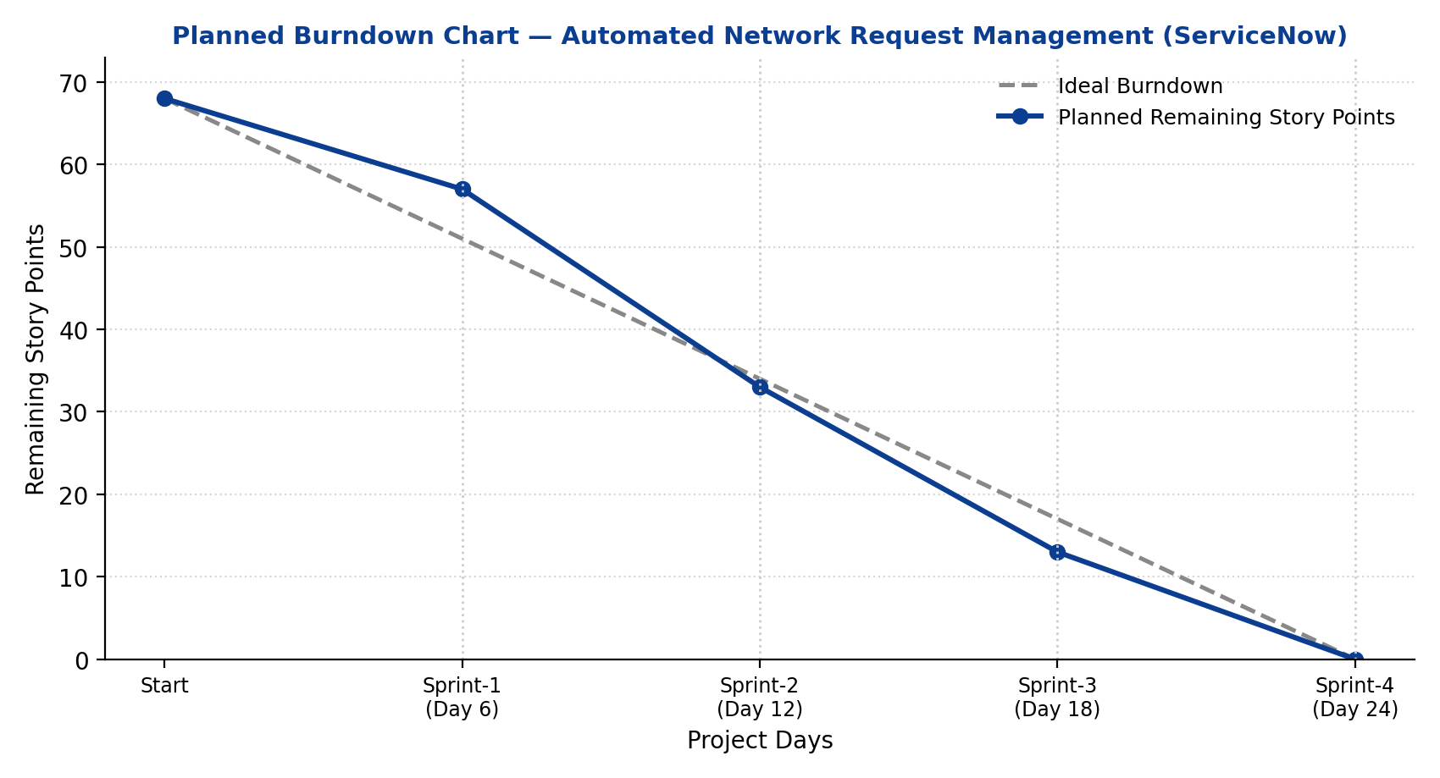
Figure 2: Planned Burndown Chart — Automated Network Request Management (ServiceNow)

